#### Cardiologic examination report

|  |  |
| --- | --- |
| καρτα2 | Exam date : 3.02.2020 **---**  **Mr. Anastasios Stylianidis**  **«Orka »**  Bull terrier  female, 22.4 kg  Age: 4 yo |

**Dr. Theodoros SINANIS**

DVM, MSc, MRCVS

*Master of Science in Veterinary Internal Medicine,*

*Specially trained in Veterinary Cardiology at the*

*Cardiology Unit of Alfort, Paris- France*

*(École Nationale Vétérinaire d'Alfort)*

*European Society of Veterinary Cardiology member*

** Medical history – clinical examination**

**History :**

* Referring physicians: **Dr. R. Giannouli – Dr. I. Zapantes.**
* Cardiologic examination in account of cardiac disease suspicion.
* Heart murmur auscultation since a young age.
* Radiographic examination: ND.
* Cardiac medication so far: **None.**

**Clinical findings** :

* Cardiac auscultation revealed a holosystolic, 2nd degree (2/6) ejection type murmur, with a PMI at the left base of the heart, at the aortic valve area.
* Lung auscultation was unremarkable.
* No cough reproduction during tracheal palpation.
* Normal femoral pulse.
* Normal mucous membranes.
* No dental calculus.
* Normal body weight (BS: 3,5/5).
* Normal peripheral lymph nodes size.

 **Echocardiography exam results**

The examination was performed with cardiac single crystal phased array probes (P 2-9 & P 1-5 mHz).

|  |  |  |  |
| --- | --- | --- | --- |
| **Parameters** |  | **Parameters** |  |
| RVDd | 8.3 mm | Ao Vmax | Vmax = 2.51 m/s |
| IVSd | 15.1 mm | P Vmax | Vmax = 1.92 m/s |
| LVDd | 35.5 mm | Ant. mitral leaflet | 3.5 mm |
| PWd | 8.3 mm | Post. mitral leaflet | 2.8 mm |
| IVSs | 16.2 mm | Mitral E/A wave | 0.86/0.77 (1.12) |
| LVDs | 21.3 mm | DT | 112 ms |
| PWs | 14.8 mm | RA/LA | 0.9 |
| FS | 40 % | Mit. reg. Vmax | - m/s |
| LA- Ao | 20.7-21.1 mm | Tric. reg. Vmax | - m/s |
| LA/Ao | 0.98 | PT/Ao | 1 |

## Interpretation

Περιγραφή: Περιγραφή: ac387 **Right parasternal and transventricular short-axis view (m-mode):**

* Normal end-diastolic LV dimensions & normal end-systolic dimensions.
* The contractility of the LV is WNL.
* Normal right ventricular dimensions.

Περιγραφή: Περιγραφή: ac387 **Left atrium examination presents:**

* The left atrial dimensions are normal at the end-systole.
* No regurgitant volume through the mitral valve, on colour flow Doppler examination.

Περιγραφή: ac387 **Right parasternal and transaortic short-axis view:**

* No anatomic lesions were found at the level of the pulmonary annulus.
* Normal pulmonic flow.
* No pulmonic regurgitation is present.

Περιγραφή: ac387 **Right parasternal long-axis four & five chamber views:**

* Normal mitral valve (anterior & posterior leaflet) appearance.
* Normal right atrial dimensions.
* Normal right to left atrial ratio.
* Thickening and hyperechoic appearance of the aortic valve leaflets.
* Mild aortic regurgitation is present.
* No interventricular nor interatrial septal defect was found.

Περιγραφή: ac387 **Left parasternal long-axis four & five chamber views:**

* Turbulent aortic flow at the level and post the aortic annulus.
* Increased transaortic flow.
* Normal transmitral flow velocity.
* No tricuspid regurgitation is present on colour-flow Doppler

Περιγραφή: Περιγραφή: ac387 **Other points:**

* No pericardial nor pleural effusion is present.
* No pulmonary hypertension is present.
* Sinus rhythm during the examination. Heart rate: 92 bpm.

### Conclusions

* Congenital **aortic stenosis at the level of the aortic valve** (valvular type), without subaortic muscular ring.
* Concerning the pressure gradient at the aortic valve the stenosis is considered as **mild (PG: 25,3 mmHg).**
* A 2nd echocardiographic examination is recommended after 12-24 months **(February 2021-2022)**.
  + **Cardiac medication :** not recommended.

**Yours sincerely:**

**Dr. Theodoros Sinanis**

[**theodsin@hotmail.com**](mailto:theodsin@hotmail.com)

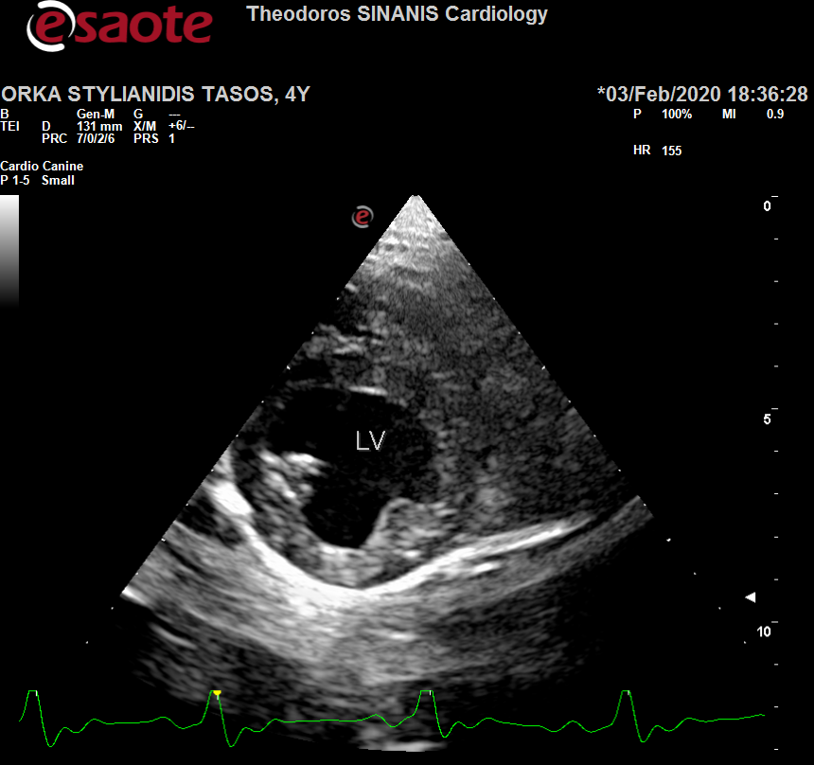 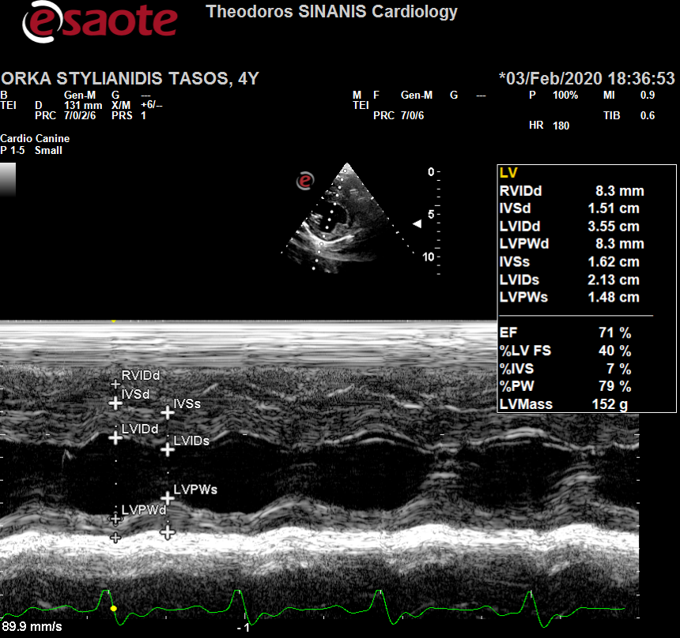

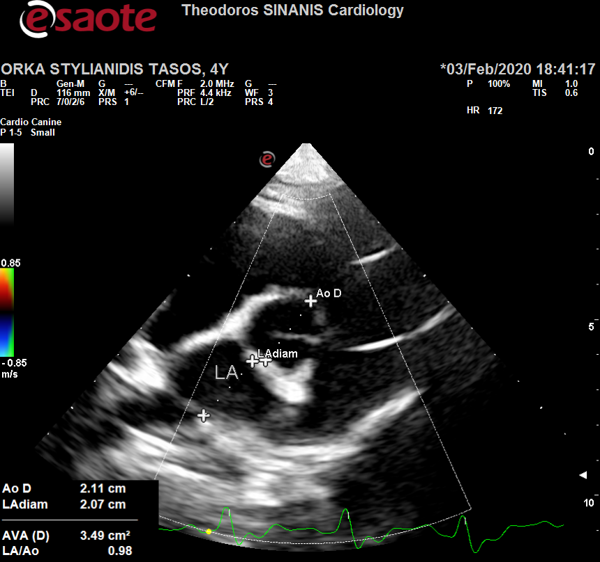 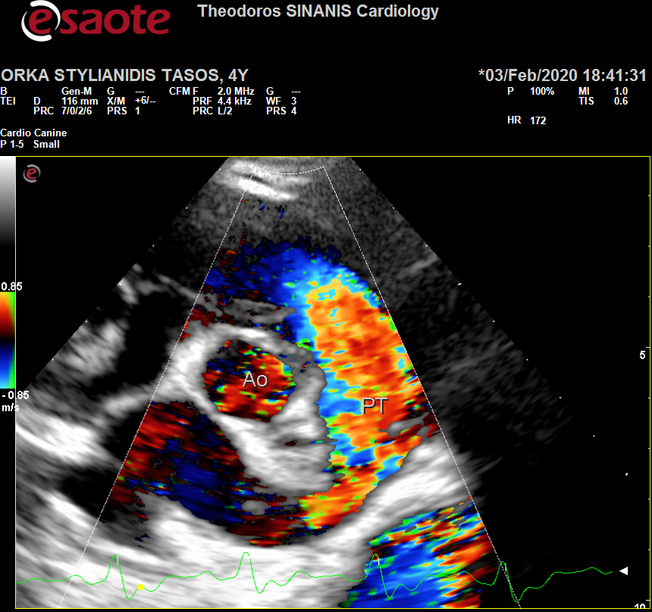

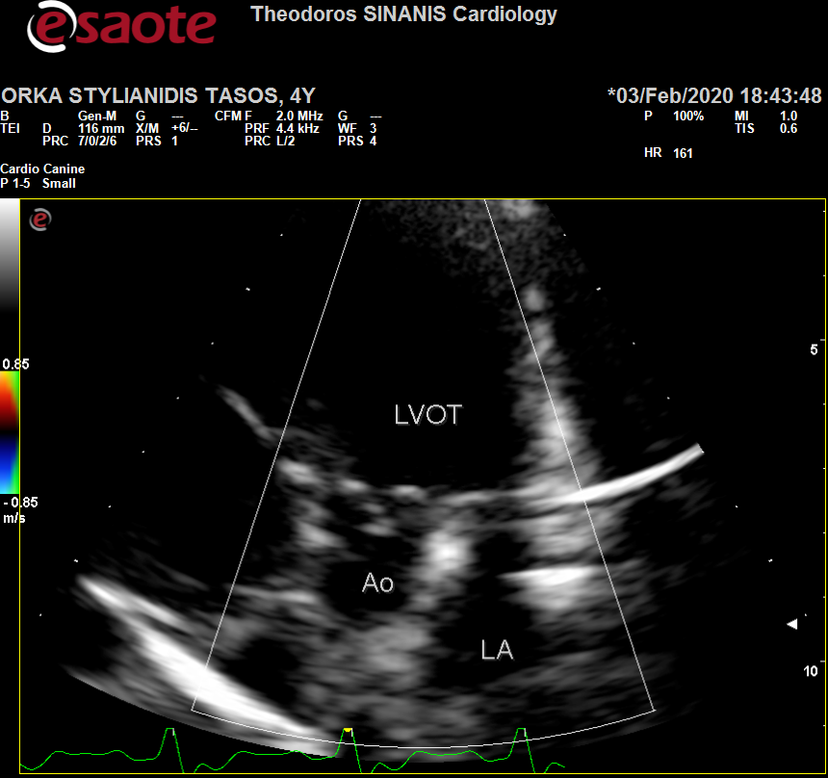 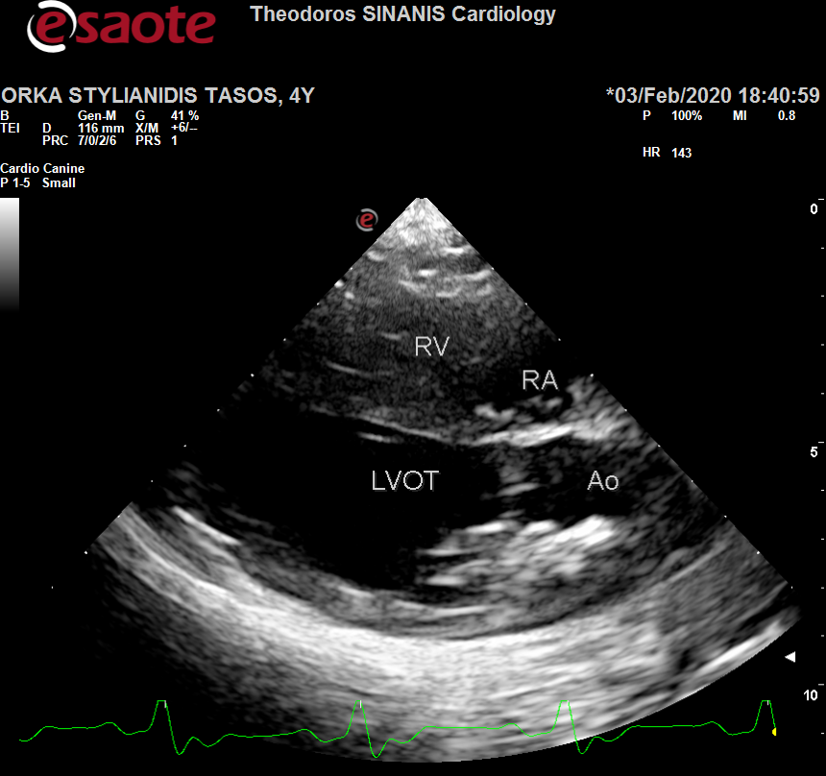

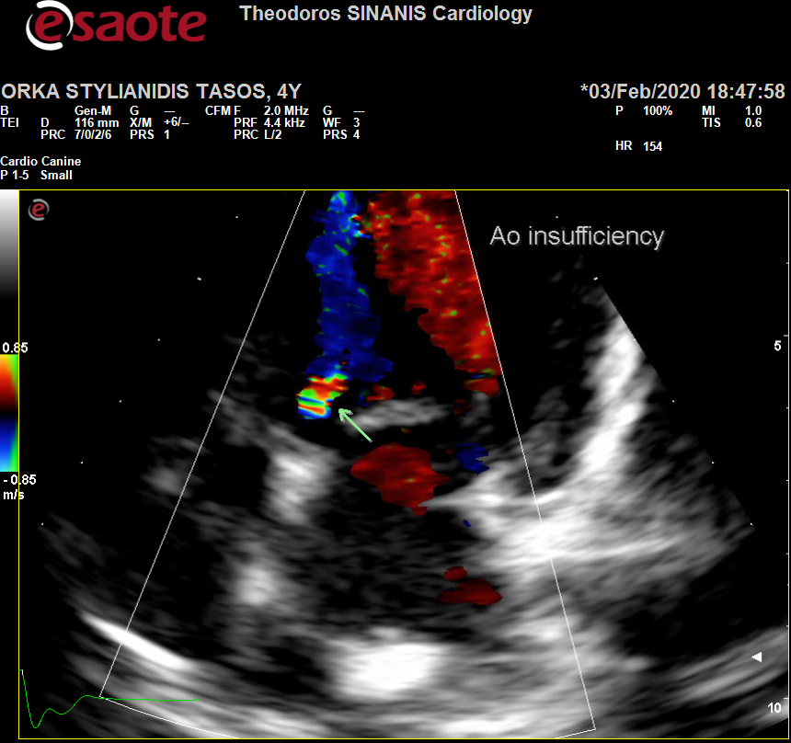 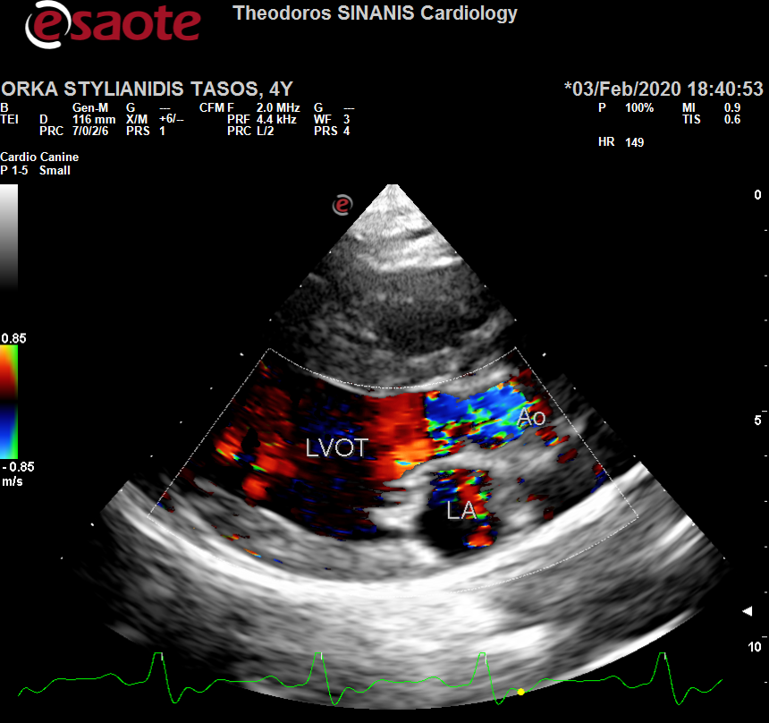

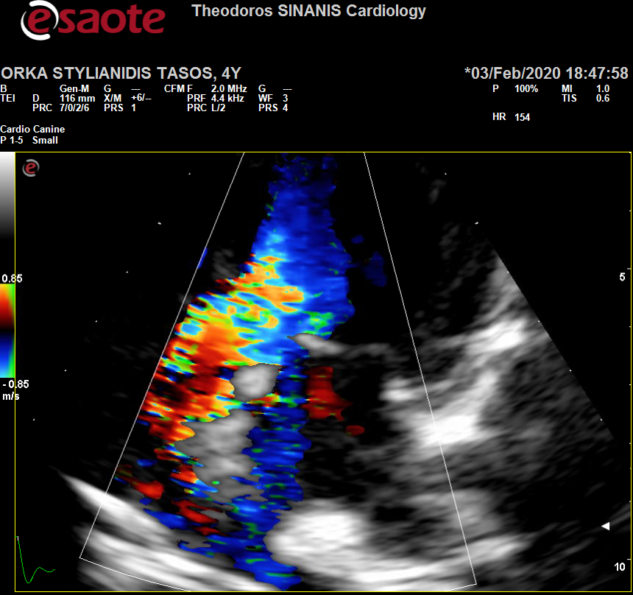 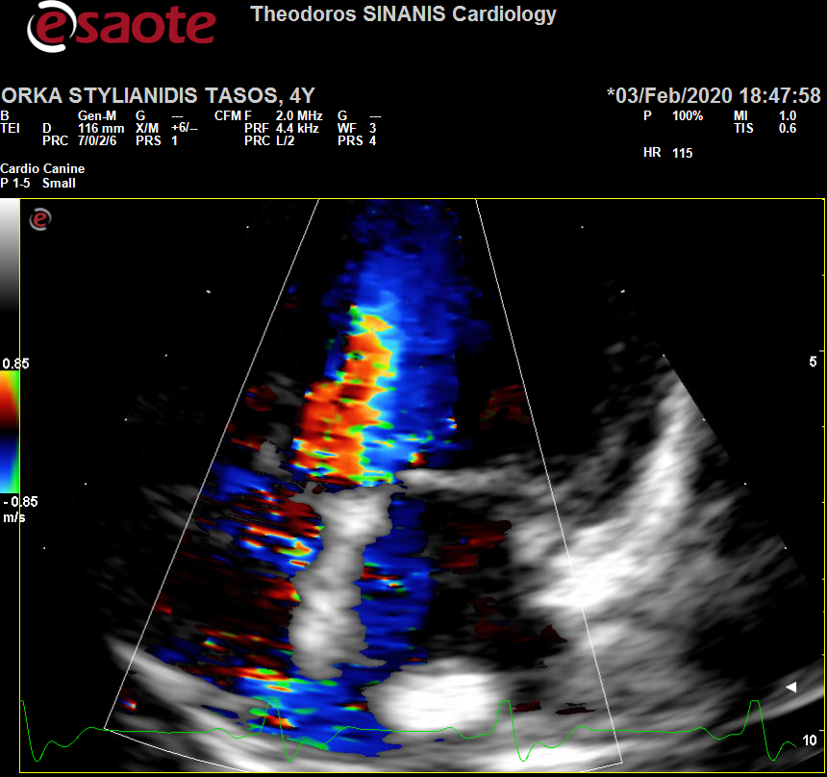

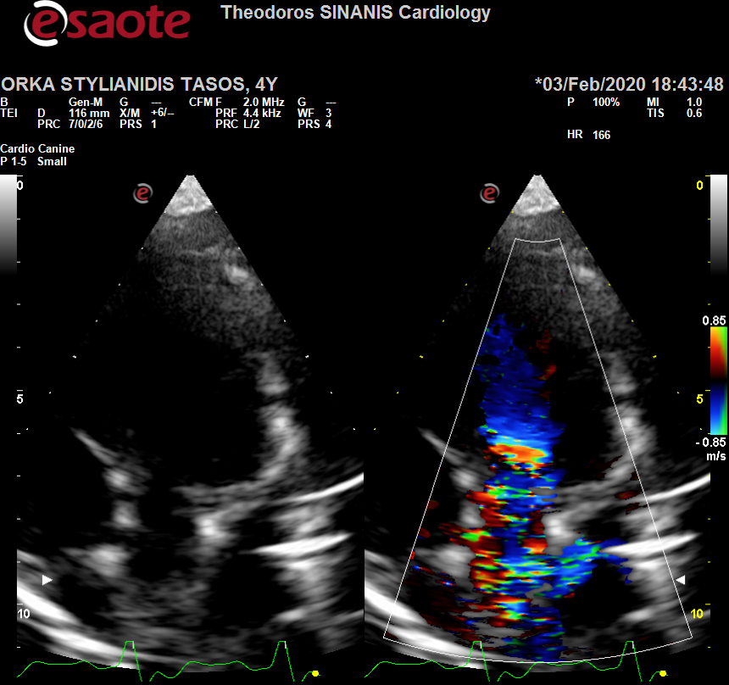 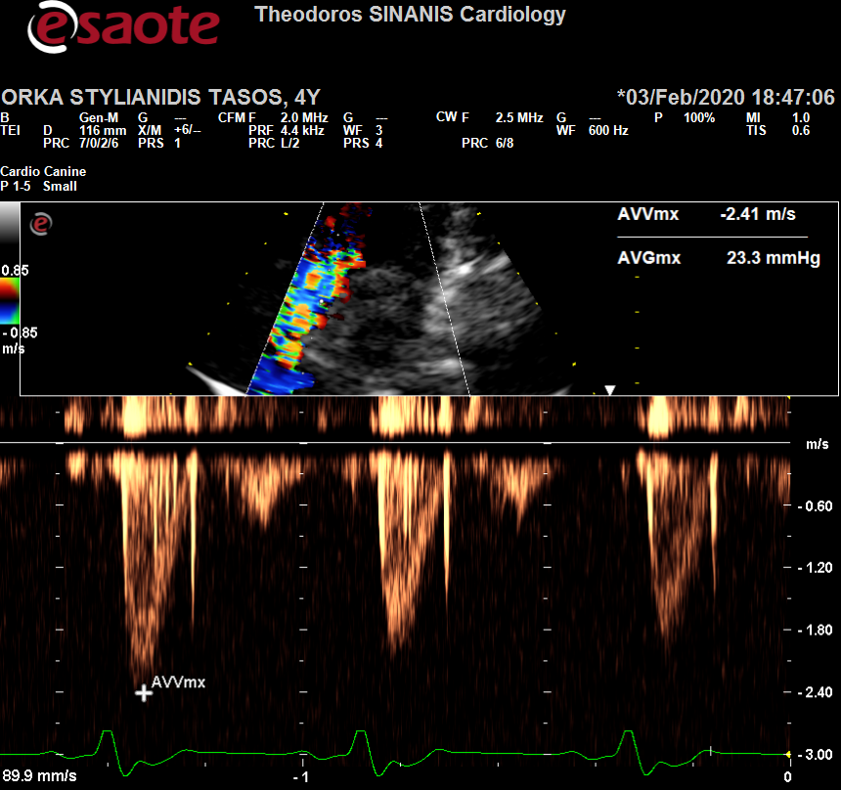Description: Description: Περιγραφή: Περιγραφή: ac387

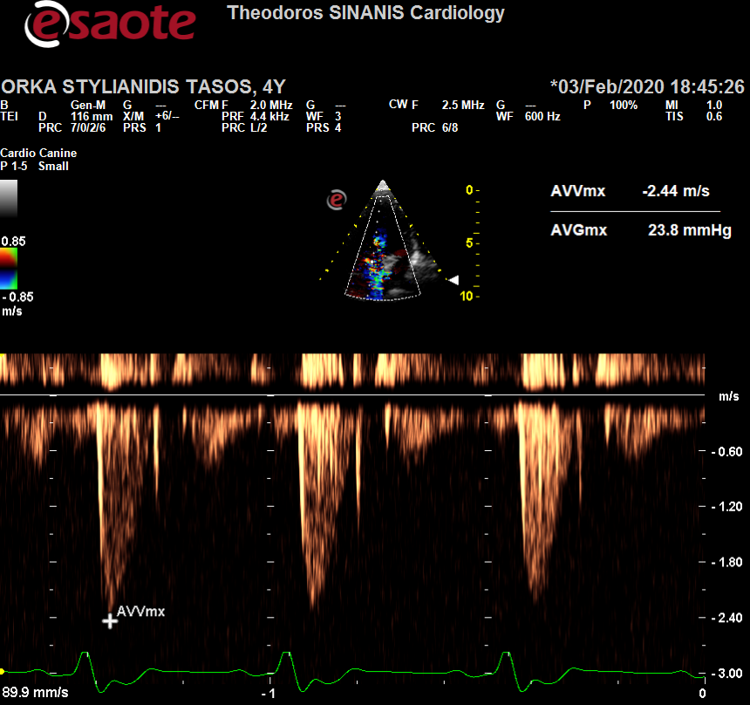 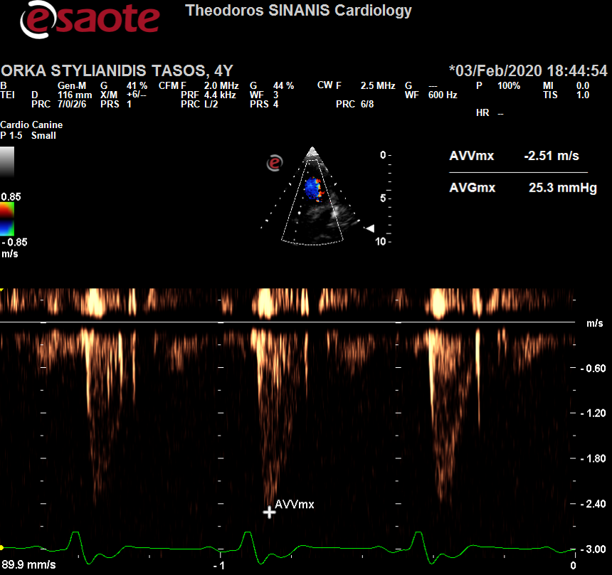

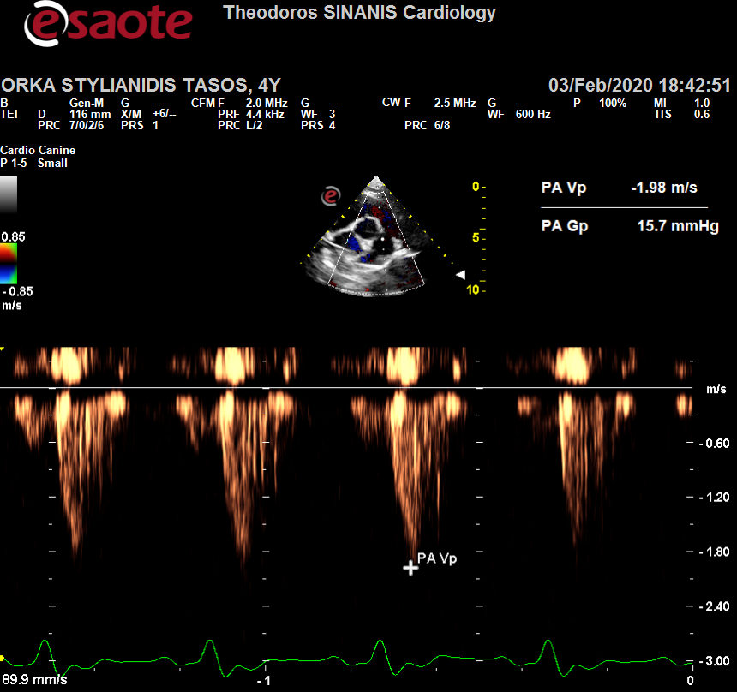 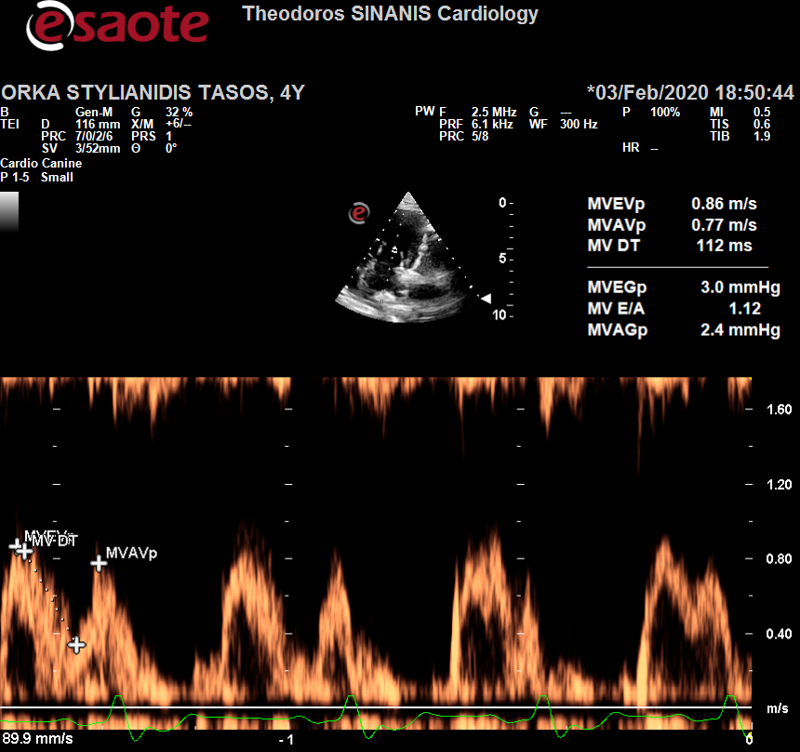

Περιγραφή: Περιγραφή: ac387